**YES BANK INICIATE TRANSFER MANUAL.**

1. LOGIN UPDATE SITE.

OTP Generate On registered Gmail ID and Mobile No.

Gmail ID is :- [accounts@mangoitsolutions.com](mailto:accounts@mangoitsolutions.com) and Mahesh sir.

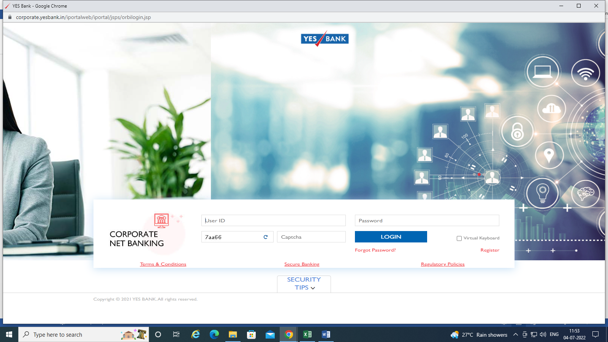

1. SELECT PAYMENT .

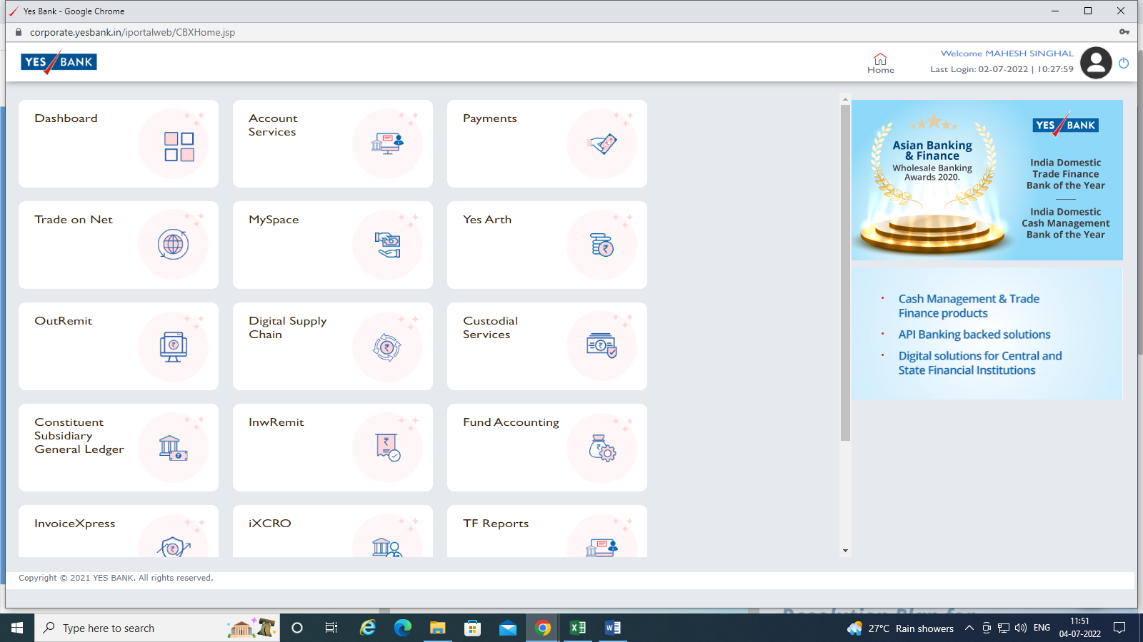

1. SELECT PAYMENTS > NEFT/RTFS/IMPS/UPI Funt transfer

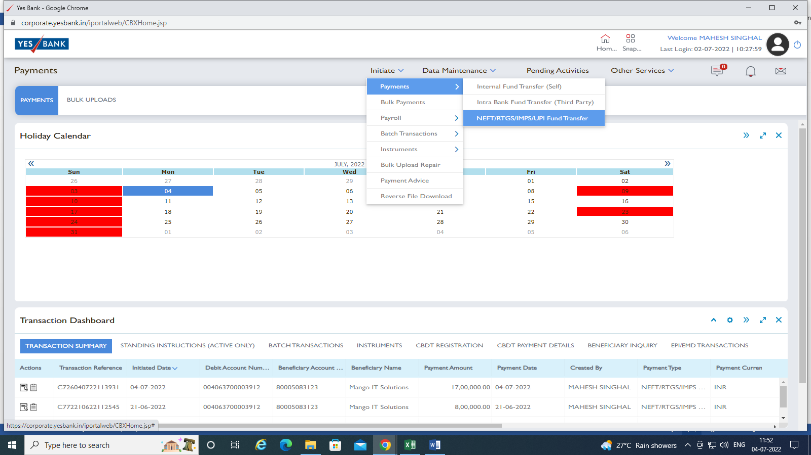

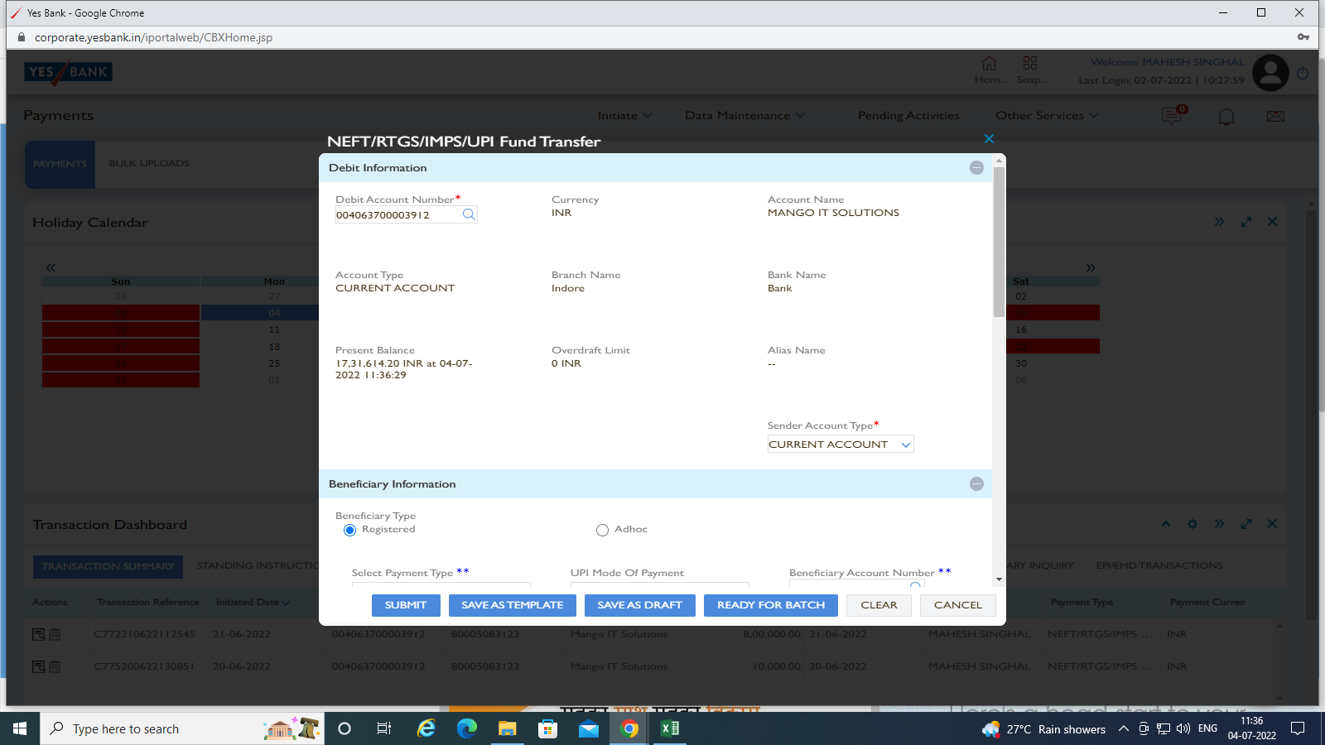

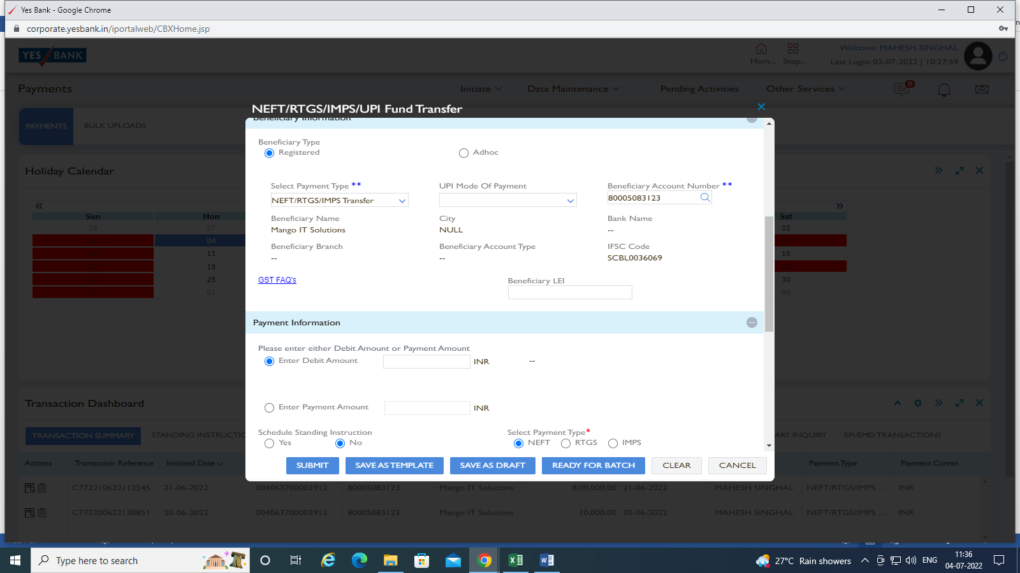

RTGS select more than Rs. 2 lac.

